**OCR GUI tutorial**

By Nick Chung

([Nicholas.chung@hotmail.com](mailto:Nicholas.chung@hotmail.com))

A Brief Introduction to Python

OCR_GUI.py is a Python program. The first step to running it is downloading python. I recommend downloading Anaconda from [Download Anaconda Distribution | Anaconda](https://www.anaconda.com/download).

Any IDE will work (Spyder is included by default) but I personally prefer Visual Studio Code, which can be downloaded in Anaconda.

Dependencies

There are several files and dependencies that need to be downloaded or installed to run the OCR GUI:

* Tesseract: the OCR (optical character recognition) engine that allows everything to work. Download the installer from [Home · UB-Mannheim/tesseract Wiki · GitHub](https://github.com/UB-Mannheim/tesseract/wiki). Take note of where tesseract is installed.
* Install all dependencies: normally one can open the CMD.exe prompt in anaconda and install them one by one, but there are quite a few. We can instead install all requirements at once with the requirements.txt file. To do this, open CMD.exe prompt and type the following line and press enter:
  + pip install -r requirements.txt
* A screenshot of a computer program

  Description automatically generated
* Please note that the requirements.txt file will need to be in the same directory as the CMD.exe prompt. In this case, the folder is C:\Users\NicholasChung. To change folders, you can run the following line in CMD.exe:
* cd C:\Users\NicholasChung\Downloads
* Which goes to the Downloads folder.
* Download the sev_seg traineddata file: this is a model that I trained on images of our specific dynamometer. It will be available on SharePoint. To install it, download it and put it in the “tessdata” folder within Tesseract. On my PC, the address of this folder is:
* C:\Users\NicholasChung\AppData\Local\Tesseract-OCR-4\tessdata
* Locate Tesseract on your PC in the code: Open up OCR_GUI.py in your IDE of choice. Line 60 will need to be changed, assuming your folders are named differently from mine. Currently the line is:
* pytesseract.pytesseract.tesseract_cmd = r'C:\Users\NicholasChung\AppData\Local\Programs\Tesseract-OCR\tesseract.exe'
* Replace this address with wherever tesseract.exe is located in your folders. Make sure the r’ before C:\ … is kept, or you may receive errors.

Run the Code

Once all the above has been performed, you should be ready to run the code. In VS code, there is a small arrow in the top right corner you can press to run the code. Running it will open up the GUI:

To begin, press the “Open” button in the top left corner. You will be prompted to open one or more videos.

Important: these videos should be edited beforehand (right click on the files and press open with Photos to do this) so that only the parts that will be read by the code are remaining.

Once you open these videos, they will show up on the side bar:

“Read” and “Flip” are checked by default. This assumes that a) you want these videos to be processed by OCR and b) they are upside down, and will need to be flipped in order to be read. You can also check the rotate button and type in the corresponding box a number of degrees to rotate the video by, if they are significantly tilted.

Once the correct boxes are checked, hit Prepare Videos at the bottom. You should see the first frame of the video:

Click on the top left corner of the screen first, and then on the bottom right corner. For best results, add a little extra space:

The two red dots are where I would click.

This will give the code an ROI (Region of Interest), which tells it where to read.

Because the training images looked like the following, we want the ROI to resemble this as much as possible for best results:

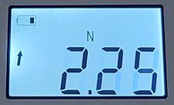

Once an ROI has been selected, the GUI will read “Videos are prepared. Press Read to begin processing”.

Doing as such will tell you how many videos are being processed, and give you a rough estimate of how long it will take, depending on how long the videos are.

If you go back into VS code or your IDE, the following should appear in the terminal:

This will tell you if the code is working or not.

Once the processing is finished, the following message will appear:

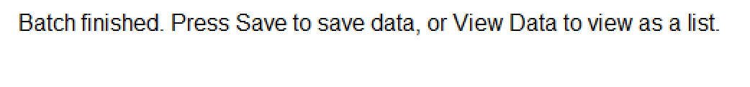

Press Save will prompt you to name an excel file and choose a folder where to save the data.